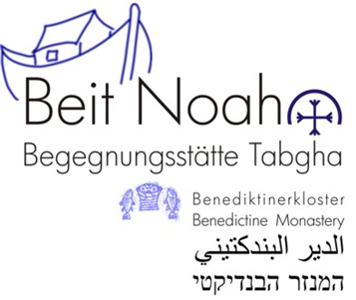
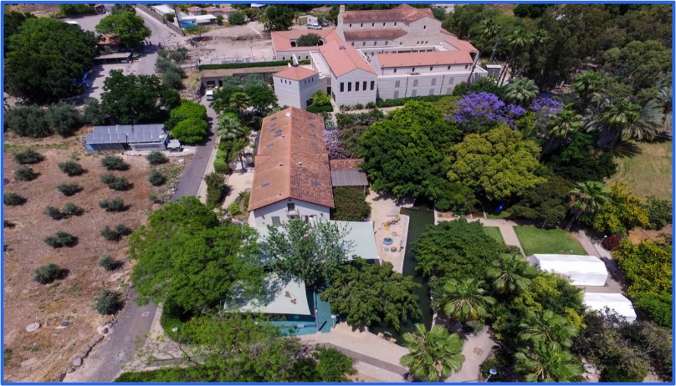

BEIT NOAH IS OPEN
The season started and we have still some availabilities in our wonderful guesthouse next to the sea of Galilee!!!
Our big house can accommodate up to 33 Persons. We rent it complete for 3500 Shekels/night or half (15 beds for 1700 Shekel/night or 18 beds for 2000 Shekels a night)!!!
You have a big kitchen + simple and comfortable rooms in one of the most beautiful places in the country!!!
Come and enjoy the simple beauty and spirituality of Tabgha, the location of the multiplication of loaves and fishes.

Contact
0542538931
Beit.noah@tabgha.net

